Client / Owner: | Losani Homes (1998) Ltd. (Losani)
Contractor: | Melloul-Blamey Construction Inc. (MB), Pollard Enterprises Ltd. (PE)
Materials: | Elastophene base sheet membrane by Soprema, Type III Grade 1 Asphalt by Bitumar, TREMprime LV primer by Tremco

Pretium was on site to review work in progress and completed to date. Installations were reviewed for compliance with provided construction and shop drawings, manufacturer written specifications, good building practice and Ownership standards. Where project specifications and drawings are insufficient, the manufacturer written specifications, generic details and application instructions will be the minimum standard for the installation. The Design Authority i.e. Architect, and 3rd Party Engineering Consultants should review all reports and advise of any issues or discrepancies with our findings or recommendations. Only items visible at the time of the site visit and at locations outlined below have been reviewed. The following was observed / discussed:
Observations / Comment
- Roofing – Building B
  - MB to confirm roof assembly to be installed:
    - The reviewed roofing package with transmittal dated July 25, 2024, calls for “2 layers of modified bitumen base sheet (sand/sand) mopped in asphalt”.
    - Conversations were had in August 2024 and a revised, unstamped roofing package was issued calling for “1 layer of Sopralene Flam 180 and 1 layer of Sopralene 180 SP 3.5MM” both of which are torch applied membranes.
    - 2 plies of Elastophene membrane (standard duty) are currently being mopped in Type III asphalt. This does not meet the intent of the specifications which call for a standard duty base sheet and heavy duty cap sheet.
  - Foreman onsite advised 2 plies of base sheet membrane would be complete throughout main roof by end of day tomorrow (Sep. 27/24)
  - PE was observed priming the concrete deck with TREMprime LV by Tremco prior to mop application of the new 2 ply membrane (Photograph P1). The system being installed is a Soprema system and Elastocol 500 primer should be used as per manufacturer’s requirements and material list submitted by PE and reviewed by MB. Pretium requested that the correct primer be used moving forward.
  - The thermometer on the asphalt kettle on the roof read 600F (Photograph P2). Contractor advised kettle thermometer is incorrect. Pretium measured asphalt temperature in kettle at 556F. Manufacturer recommended max. asphalt temperature of 550F (Photograph P3). Contractor to ensure maximum recommended temperature is not exceeded.
  - Asphalt temperature in mop bucket was measured at 426F which is within the EVT range of 430F ±25F for mopping (Photograph P4).
  - Membrane plies are being walked/kicked into place (Photograph P5). This is resulting in inadequate bonding at side (Photograph P6) and end laps (Photograph P7). Pretium requested membrane plies be broomed into place as per good roof practice moving forward.

  - The second ply of base sheet membrane is being applied in the field of the roof prior to the installation of the base sheet flashing (Photograph P8). Foreman onsite advised membrane flashings will be installed after 2 ply field membrane is complete. Pretium has concerns that the field and flashing membranes are not properly interwoven (1st ply field, 1st ply flashing, 2nd ply field, 2nd ply flashing) as detailed and per manufacturer’s requirements, and that this detail may be compromised. Pollard to provide written confirmation from Soprema that this is acceptable, or what modifications to the detail are required.
  - Sopraflash Flam Stick self-adhered membrane by Soprema is onsite (Photograph P9) as is SA Primer by Johns Manville (Photograph P10). The system being installed is a Soprema system and Elastocol Stick primer should be used as per manufacturer’s requirements and material list submitted by PE and reviewed by MB. Pretium requested that the correct primer be used.

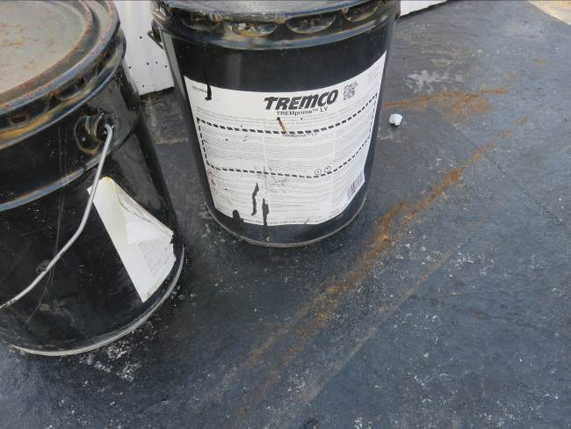 | 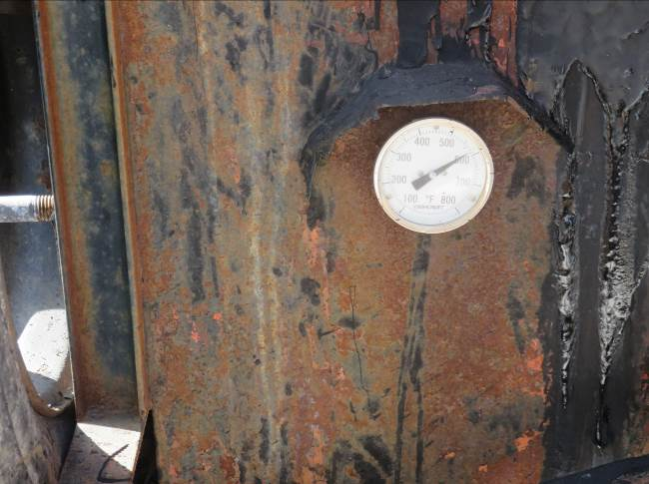
- Tremco TREMprime LV primer was being applied to the concrete deck. | - Thermostat on asphalt kettle reads 600F.
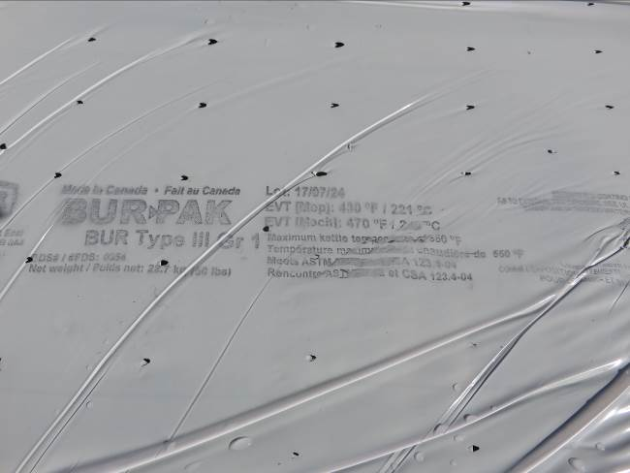 | 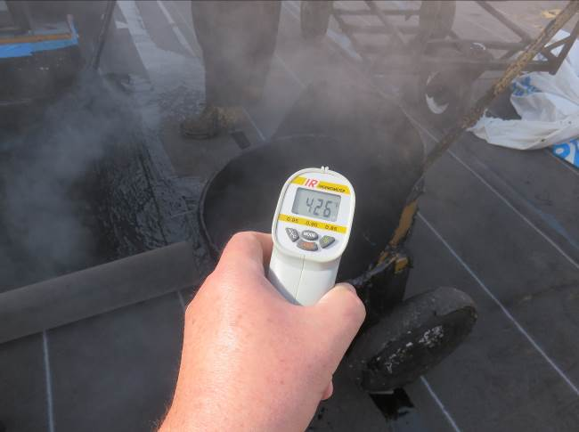
- Manufacturer recommended max. asphalt temp. is 550F. | - Temperature of asphalt in mop bucket measured at 426F.
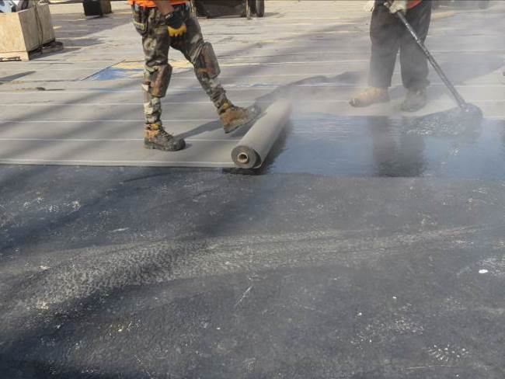 | 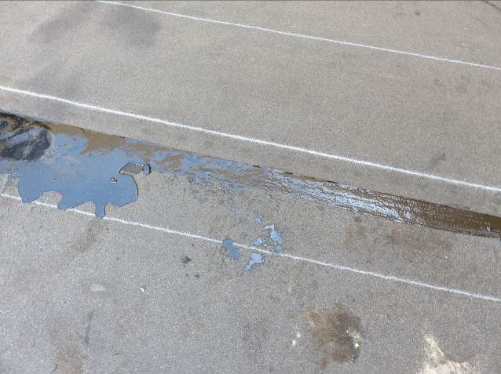
- Membrane is being walked/kicked into place. | - Voids in asphalt at side lap resulting from insufficient/ inconsistent pressure being applied during installation.
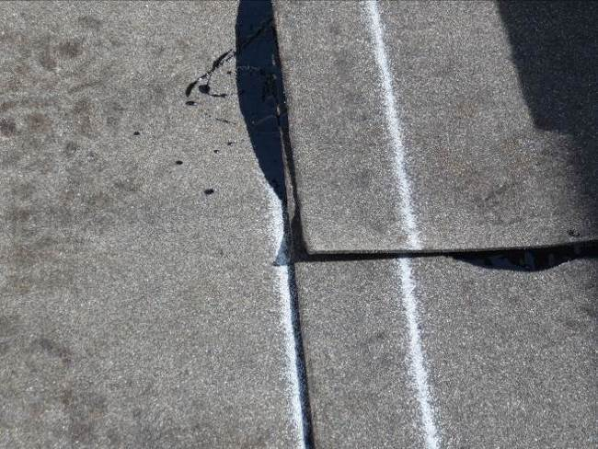 | 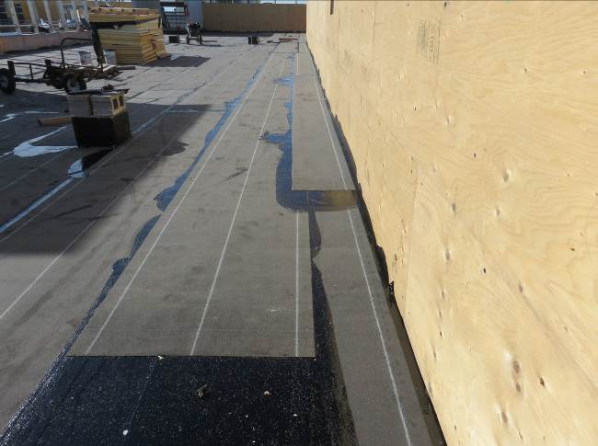
- Membrane corners lifting resulting from insufficient/ inconsistent pressure being applied during installation. | - Second ply of field membrane is being installed prior to base sheet flashing.
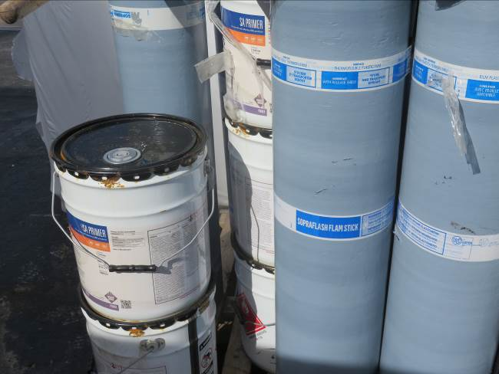 | 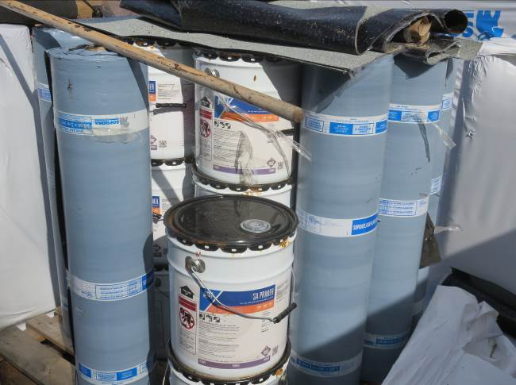
- Sopraflash Flam Stick self-adhered membrane by Soprema is onsite. | P10: SA Primer by Johns Manville is onsite.

This report was issued to all parties on November 7, 2026. The deficiency list has been uploaded to Procore.
Trade foreman was verbally notified of report contents. This report pertains to work specifically requested and comments only on operations and items that were visible or being undertaken at the time of our inspection.
Report by: | Dave Neal, RRO | Reviewed by:

